

We are kind – We show respect – We work hard – We are honest
Newsletter Spring 1 2026 - No. 5
09/01/26
Dear families,
Welcome back, children and families, and a very Happy New Year to you all! We hope you enjoyed a joyful and restful Christmas break and are feeling refreshed as we begin this new term together. As we step into the year ahead, winter has certainly made its presence known, with very cold temperatures and icy, snowy weather all around us. Please take extra care when travelling to and from school, wrap up warmly, and join us as we look forward to a safe, happy, and exciting start to the new year.

Reading
At Standhill Infants’ School, we believe that reading is a vital skill that lasts a lifetime. We encourage you to read with your child regularly—ideally at least three times a week—and to record each reading session in their reading diary.
When your child reads three times in a week, they will earn a sticker for their bookmark and a raffle ticket. The raffle ticket will be placed in our weekly draw, and if your child’s name is selected, they will receive a small prize at the end of the week.
Thank you for supporting your child’s reading journey!

Front garden
After many years of looking after our front garden, Mrs Ann Gilbert and her husband have decided to hand over the responsibility to someone else. We thank them for all the work they have done on the front garden and for keeping it looking beautiful for so long. With this in mind, we are still looking for someone or a family who would like to take care of the front garden for us. If you would like to, please contact the school office.

New phonics programme
We are excited to share that we have launched a new phonics programme in school called ELS, which is being taught across all year groups. ELS provides a clear, consistent structure for teaching phonics, ensuring that all children build strong foundations in reading, spelling, and confidence with sounds. By using the same programme throughout the school, children benefit from familiar routines, shared language, and a smooth progression of skills, helping them to become fluent and enthusiastic readers as they move through each year group.

Holidays in term time
As we look ahead to the spring and summer months, we would like to remind parents and carers of the importance of planning family holidays during the designated school holiday periods rather than during term time. Regular attendance plays a crucial role in children’s learning, progress, and wellbeing, and time missed from school can have a significant impact.
Please note that, in line with updated Department for Education guidance, the school’s attendance policy is being revised. As a result, holidays taken during term time will not be authorised, and a fixed penalty notice will be issued via Nottinghamshire County Council (see separate letter for further details).
We appreciate your continued support in helping us maintain high attendance and ensure that every child is able to make the most of their learning opportunities.
Pupil absence
Just a reminder to please inform the office if your child is unwell by calling 0115 8476787 or emailing office@standhill.notts.sch.uk.

If you are running late for the start of the school day, please notify the office as soon as possible—especially if your child requires a school dinner, as meals are ordered by 9:30am.

P.E Kits
Recently we have noticed that children are arriving in PE kit that doesn’t follow our school policy.
Please ensure that your child arrives for P.E in the following clothing:
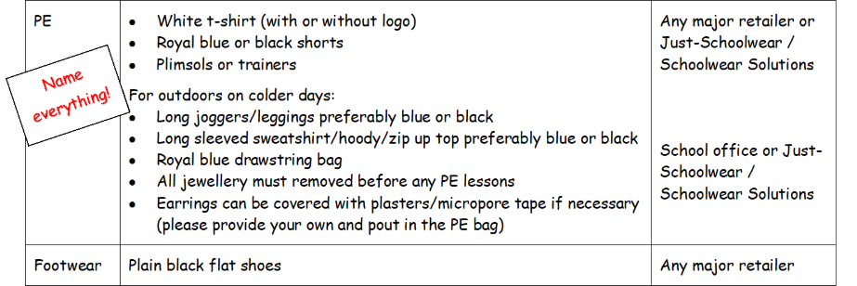

Diary Dates

Date | Activity
Monday 5th January 2026 | School re-opens for Spring 1
Monday 16th February – Friday 20th February 2026 | School closed for half term holiday
Monday 23rd February 2026 | INSET DAY – School closed to all children
Tuesday 24th February 2026 | School re-opens for Spring 2
Tuesday 24th February 2026 | Dental Survey – letter to follow
Week commencing 2nd March 2026 | Parents’ Evenings/Reviews – Letter to follow
Thursday 5th March 2026 | World Book Day
Friday 20th March 2026 | Red Nose Day – dress in red, bring £1!
Monday 23rd March – 27th March 2026 | Health and Safety Week
Thursday 26th March 2026 | Life Education Science Visit
Friday 27th March 2026 | Easter Bonnet Parade – Letter to follow
Monday 30th March – Friday 10th April 2026 | School closed for the Easter holidays
Monday 13th April 2026 | School reopens for Spring 2 2026

More dates will follow as the term progresses.
Kind regards,
Mr T Fennell,
Headteacher

