Welcome to ....



2024-2025

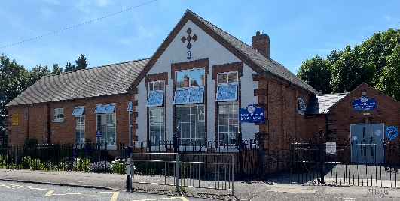
Dear Parents and Carers
WELCOME TO STANDHILL
INFANTS’ SCHOOL


We are delighted to welcome you to the Standhill family. We hope your time with us is happy and memorable. The staff team work hard to build close relationships with families to enable the children in our care to get the very best school experience that we can offer. I hope the information in this booklet is helpful. We will meet early in the term to share more detailed curriculum information. In the meantime, please browse our website at:
https://www.standhillinfants.co.uk/ and feel free to email office@standhill.notts.sch.uk with any questions.

Kind regards
Mrs Sarah Ghattaora, Headteacher

ETHOS STATEMENT

Standhill Infants’ School is a happy, friendly, welcoming school with a truly inclusive family atmosphere. We put the wellbeing and safety of the children at the heart of everything we do. Children, staff and governors work hard to ensure that everyone can be proud of their achievements. The Standhill family are kind and caring citizens, who celebrate diversity and show respect.



OUR CORE VALUES
We are kind – Dizzy dolphin is kind and shows reciprocity

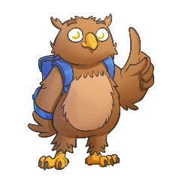
We show respect – Peanut Elephant shows respect and is resourceful
We are honest – Blinky Owl is honest and reflective
We work hard – Slider Penguin works hard and is resilient

OUR SCHOOL TEAM
TEACHERS
Mrs S Ghattaora, Headteacher
Miss R Randall, Deputy Headteacher / FS Leader Class 1 teacher (Reception)
Mr C Worrall Class 2 teacher (Reception)
Mrs L Wardell, Class 3 teacher (KS1 class)
Mrs L Taylor (job-share), Class 4 teacher (KS1 class)
Mrs A Thompson (job-share), Class 4 teacher KS1 Leader / SENCO
Miss K Glover (job-share), Class 5 teacher (KS1 class)
Mrs N Magiera (job-share), Class 5 teacher (KS1 class)
Miss J Holland-Smith, PPA teacher (music)

TEACHING ASSISTANTS

Mrs J Clarke
Mrs L Bakewell
Mrs H Osborne
Mrs N Rickman
Mrs J Smith
Mrs C Wing
Miss R Wollacott

SCHOOL OFFICE
Mrs F Parr (School Business Manager)
Mrs D Mear (Admin Assistant)

SITE MANAGER
Mr R Mann

KITCHEN ASSISTANTS:
Mrs T Soar
Mrs B Bernard

MID-DAY SUPERVISORS
Mrs B Border
Miss S Smalley
Mrs P Mackereth
Miss K Rooney
Mrs A Brennan

GENERAL INFORMATION

There are some forms included in this pack which we would be grateful if you could complete in capitals giving as much detail as possible. This information is confidential. Please also remember to bring your child’s birth certificate to school as you are required by law to present it to us.

A Quick Note Regarding Who Has Parental Responsibility

There is much confusion regarding parental responsibility for unmarried/divorced parents. Please read through the guidelines below to help you establish whether your child’s mother/father has parental responsibility:
- Mothers automatically have parental responsibility and will not lose it if divorced.
- Fathers married to the mothers at the time of birth automatically have parental responsibility and will not lose it if divorced.
- Unmarried father automatically has parental responsibility if he is registered on the birth certificate.
- If a child was registered and the father was not named on the birth certificate, then the child can be re-registered to include the father's name. Once this has been done, the father WILL have parental responsibility.
The only exception is where there is a Court Order and it is vital that you inform us if this is the case.

1 SCHOOL TIMES 8.40am – 12.00 lunch 1.00 - 3.10 pm
If your child is in Class 1, please take him/her onto the rear playground where they will be asked to line up in their class lines when the bell rings at 8.40am. They will then be taken into school by their class teacher and teaching assistant.

If your child is in Class 2, please take him/her to Class 2’s exterior door at the side of the school on the way to the rear playground entrance.

The back door and side gate will be closed at 8.45am. It is important you arrive on time, but if you are late you will need to enter by the front entrance and register in the late book. For further information, please read the Attendance Policy on our website.

At the end of the school day, your child will come out through the same door used to come into school in the mornings. The teacher will match child to parent one at a time for safety reasons. You will need to wait until your child is at the front of the queue before you can take them.

2 OUR SCHOOL DAY

8.40 to 10.15am - Session 1
10.15 to 10.30am - Playtime
10.30 to 12.00pm - Session 2
12.00 to 1.00pm - Lunchtime
1.00 to 2.15 pm - Session 3
2.15 to 2.30 pm - Playtime
2.30 to 3.10 pm - Session 4

Weather permitting, Foundation Stage children (also called reception children) use the outside classroom on a daily basis.

Lessons are taught through topics linked to the children’s interests. These change termly or half-termly. (Please see curriculum topic planning on the school website.)

In the Foundation Stage, children will have daily English and maths inputs from their teacher. They will also access adult focus tasks, where children work on a specific learning activity with a teacher or TA. Children also have opportunities to work individually or with friends on the continuous provision activities around the classroom. These are carefully planned and resourced by the teacher to develop key learning.

We use the “Active Learn Bug Club” Scheme to teach phonic-skills and children access phonics lessons daily. (The scheme of work is available on the school website.) The children also read regularly to the teacher, beginning with 1:1 and then when ready, “guided reading” sessions.

All children have PE lessons, and their PE kit needs to remain in school.

Our Foundation Stage children are very much part of school. They share lunchtime with the KS1 children and attend some assemblies during the week eg Super Learners assembly, where teachers celebrate efforts made by the children during the week.

We use the “White Rose Maths” Scheme to teach mathematical skills alongside Numberblocks materials. (The scheme of work is available on the school website.)

3 ILLNESS/ABSENCE

If your child is going to be absent from school due to illness, please notify us by ringing the school office on 0115 8476787 before 9.15am (where you can select the option to leave an answerphone message). We have a duty of care to account for the whereabouts of your child if they are absent. If your child is not in school and you have not left a message, you will be contacted on the first day of their absence by a member of staff.

It is your legal duty to ensure your child attends school regularly and on time. No holiday taken in term time will be authorised and could result in a fixed penalty notice fine.

If your child is well enough to be in school, but needs medicine, there will be one or two staff who will be available to administer it. Please see the medicine policy on our website and complete a form from the school office.

4 INDEPENDENCE

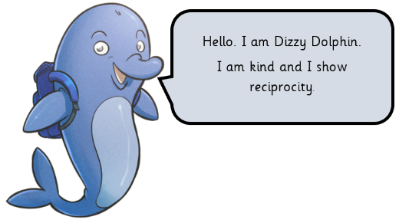
During their time at Standhill, we encourage our children to become independent thinkers and learners. They are supported to develop their ability to be effective learners with the help of our “Learning Buddies”:


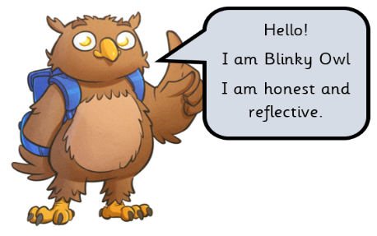
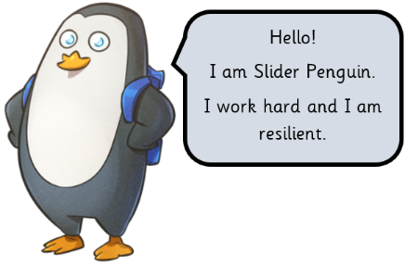
The school adults will support your child but will also encourage them to ‘have a go’ for themselves.

You can help us develop their independence by giving your child the opportunity to get dressed and undressed by themselves, so that when they start school, they do not have to worry about getting changed for PE. Please ensure you have shown children their PE kit and other personal belongings before they start school so they can identify them.

As they get older, children are encouraged to change their reading book, be responsible for their possessions, eg hanging up their coat, putting letters in their bag, etc.

5 HELPING YOUR CHILD

The best way to help your child is to ensure they attend school every day.

Once settled your child will bring home a reading book and will exchange it weekly. Please support us in hearing your child read every day if possible. Little and often is the best way. Your child will receive a password to access “Active Learn” our online reading resource.

We also email letters to you relating to activities in school, eg theme days and trips. Please check your emails regularly.
Home learning challenges are shared with you via the school website.

6 WAY INTO SCHOOL / ROAD SAFETY

The main entrance gate gets congested; therefore, you may bring your child through the car park, but for your child’s safety please bear in mind that it is a car park and as such cars may occasionally be driven in and out of it.
If you bring your child to school in a car, please DO NOT PARK in the school car park, in front of the school gates or on the school entrance zig-zag markings which are painted on Standhill Road as this ensures a clear view up and down the road for children to cross the road safely. It is illegal to park on these lines and Nottinghamshire County Council have mobile units, which regularly check parking outside school. We have an excellent relationship with the local residents - please respect this by parking considerately when dropping off or collecting your child.

Please ensure that an adult accompanies your child to and from school. Do not leave your child unaccompanied in the school playground. Your child will only be dismissed at the end of the day to a person named on the collection sheet, who must be at least 16.

7 SCHOOL SECURITY

During the school day, all gates except the front gate are locked as well as the external and internal front doors. If you are late bringing your child to school, you will need to enter by the main entrance and sign your child in with an explanation of why they are late. Likewise, if you need to take your child out of school early, you are required to sign them out – with an explanation also! This is so we can account for your child in the event of an emergency, eg fire. All visitors are required to sign in. Visitors will not be left unaccompanied unless they have valid Disclosure and Barring Service (DBS) certificate.

8 CONTACTING THE CLASS TEACHER

If you wish to speak to your child’s teacher, you can:
- wait until the children have been dismissed at the end of our school day,
- make an appointment for a mutually convenient time or email the teacher on their class email.

These are class1@standhill.nott.sch.uk, class 2@…. and so on.

Please note that teachers should only be contacted for urgent reasons when the school door opens in the morning, as this is the time when the children need them for the start of their school day.

9 MILK IN SCHOOL

Free milk is available for all school children under the age of five and is funded by the UK Government. In our school, this milk is provided by Cool Milk. If you would like your child to have milk, please register as follows:

If your child is under five:
- Register online at www.coolmilk.com
- Register by a Tuesday at 5pm for your child’s free milk to start the following week
- Free milk will continue until the Friday before your child’s fifth birthday. You will receive a payment request four weeks before their birthday - if you wish your child to continue to receive school milk, simply make a payment.

If your child is five or older:
- Register and pay online at www.coolmilk.com
- You can pay Cool Milk either online, over the phone or at a local PayPoint in half-termly, termly or annual instalments.
- Please pay by a Tuesday at 5pm for your child’s milk to start the following week

All information handled by the Cool Milk group is processed in accordance with the Data Protection Act 1998. All personal information is securely stored on Cool Milk’s UK servers and is never passed on to third parties without your permission.

10 MID-MORNING FRUIT

Our school takes part in the National School Fruit Scheme. Children are given a free piece of fruit every day as part of our healthy eating policy. If you are available for approximately 15 minutes per week to wash fruit one morning a week and would like to help, please let us know.

11 WATER BOTTLES

The children must bring a water bottle every day. The bottle must:
- Be made from plastic or metal (no glass or ceramic).
- Be a sports type cap – (no screw-tops) so the children can manage it themselves.
- Have your child’s name clearly labelled on it.
- Contain only plain water (filled at home).
- Be taken home at the end of the school day to be refilled and returned the next day.

12 FIRST AID SLIPS

There are some occasions when a child has a minor accident at school when staff do not think it urgent enough to contact you immediately. In this instance, a first aid slip will be completed and sent home with your child.

If your child sustains a significant bump, we will ring you. Please be assured that should we feel your child needs urgent medical attention we will call 999 and contact you immediately. If we cannot get hold of a parent, then we will try contacting the other emergency contacts on the list.

May I emphasise that it is very important for the school to be kept informed of any changes in the emergency arrangements for your child eg change of telephone number, a change of parent’s place of work and who to contact in an emergency.

13 SCHOOL UNIFORM – NAME EVERYTHING!

Our school uniform is royal blue and grey. Royal blue jumpers, cardigans and sweatshirts, grey trousers, skirts and pinafore dresses, with white or pale blue polo shirts. Uniform does not need to display the school logo, but items do need to be of the correct colour. Long hair should be tied up and jewellery is not allowed apart from stud earrings, which must be removed or covered for PE. Please see Mrs Ghattaora if your child wears jewellery as part of the family’s cultural or religious beliefs. Watches are not allowed.

Your child will also require a PE kit and a PE bag which will be kept on their peg in school. It should consist of:

- Indoor kit - white T-shirt, blue/black shorts
- Outdoor kit - leggings/jogging bottoms and a warm top. Plimsolls/trainers with elasticised fronts or Velcro.

Our school sweatshirts and T-shirts can be brought either from Schoolwear Solutions – www.schoolwearsolutions.com, or from Just-School Wear Ltd – www.just-schoolwear.co.uk. Some second-hand items are available from the school with a wider selection available from Second Chance on Carlton Hill. Please refer to our Uniform Policy enclosed with this pack.

Your child will also need a book bag which your child brings to school every day. (Book bags are stored in boxes in the classrooms; therefore, please DO NOT send a backpack or bag of any other kind, as storage is limited – this will be sent home at the start of the day.

PE bags and book bags are available to purchase from our uniform stockists or the school office.

Your child will need a coat. Please make sure your child’s coat has a loop big enough to hang the coat on our cloakroom pegs.

PLEASE LABEL ALL ITEMS CLEARLY WITH YOUR CHILD’S NAME.

14 LOST PROPERTY

We do our best to match up items straight away, but we also have a lost property box. This is kept in the front cloakroom. Please ask if your child loses something in school. Do not send precious things (toys/jewellery/watches etc.) to school because if they are lost it can cause distress.

15 PARENT HELPERS

We are open to offers of help from parents who wish to volunteer in school. This could be to hear readers, help with washing fruit first thing or in bookshop. Please note that you would be required to undergo DBS clearance. Please ask at the office for more information.

16 OUR SCHOOL GOVERNORS

- Mrs J Bucknall (Chair) (Co-opted)
- Miss S Flint (Parent Governor)
- Mrs S Ghattaora (Headteacher - Standhill Infant School)
- Mrs J Clarke (Standhill Infants’ School) (Non-Teaching Governor)
- Mr C Worrall (Co-opted)
- Miss N Scott (Co-opted)
- Mrs S Britten (Co-opted)
- Mr T Morley (Local Authority)
- Miss M Duncan (Parent Governor)
- Mrs A Croghan (Parent Governor)

Parent governors are elected by the parents of pupils at our school. They are elected for four years. They do not have to stand down if their child leaves the school during that period, though they may do so if they wish. The parent governors are your representatives and can make your views known to the full Governing Body which meets once every term. All Governors can be contacted via school.

17 BENEFITS-RELATED FREE SCHOOL MEALS

If you are in receipt of certain benefits, we would ask that you check whether your child is entitled to benefits-related free school meals, which you can do by following this link: https://www.nottinghamshire.gov.uk/education/school-meals/free-school-meals-and-milk.

Not only do we receive additional funding to support your child in school, but you will also be entitled to free milk once your child has turned five, free school trips, a free after school club once a term, a free reading folder/book bag and a PE bag with shorts and a T-shirt.

18 SCHOOL MEALS AND LUNCHTIME SUPERVISION

You may choose whether your child has a school dinner or a packed lunch from home or a combination of the two! There is a form also enclosed with this pack to complete for your child’s first term. Please return this as soon as you can before the end of the summer term.

If your child is going to be late for school on any day or has a medical or dental appointment during the morning, please telephone or email the school office to ensure a school meal is ordered for that day if your child is having one.

The supervision of children is organised by a team of midday supervisors. There are 5 lunchtime staff, and together they are responsible for the safety and welfare of the children throughout the lunch break.

As you may be aware, all infant school-aged children have been entitled to a free school meal since September 2014 under the Universal Infant Free School Meal scheme. Menus for the Autumn/Winter term are enclosed with this Welcome Pack and can also be found on our website. Dinners should be ordered for the three-week cycle for the term. Menus are changed twice a year. Alternative menus are only provided for those with medical/special dietary requirements, vegetarians and religious observances.

All menus comply with Food Standards Agency guidance and new forthcoming European Government legislation, requiring Allergen Foods to be ‘visibly, clearly and legibly displayed’. These 14 Allergen foods are: Peanuts, Nuts, Milk, Soya, Mustard, Lupin, Eggs, Fish, Shellfish, Molluscs, Cereals Containing Gluten, Sesame, Celery, Sulphur Dioxide.

Parents/carers are required to complete and return a dietary request form available from the school office if their child has any of these 14 allergies.

This form will be retained against the pupil file, copied to the school chef and a copy sent to the Food Development Manager for registration and to ensure the dietary requirements are provided for the pupil. Parents/carers will be asked to supply a medical/dietician’s letter to support the special diet requirements in order to avoid self-diagnosed or personal food preference choices being requested.

Packed Lunch From Home

- Please send the healthy packed lunch in a lunchbox with your child’s name on it and a spoon for yoghurt if required.
- No more than one treat style snack, eg biscuit/crisps/chocolate bar.
- A small non-fizzy drink may be provided (but no glass please).
- It would be helpful if you could send fruit ready prepared and wrapped in cling film to keep it fresh.

18 MESSAGES SENT HOME

As a school, we are committed to keeping parents regularly informed about what’s going on. The majority of our letters and texts will be sent electronically. We use the ScoPay software system for this. Please make sure we have your correct email addresses and mobile phone numbers.

19 OUR SCHOOL WEBSITE

It is worth saving our website address in your “favourites” as we post information and photos about events we hold in school as well as relevant documents such as policies, leave of absence forms, etc. You will also find the latest newsletter here with the most up to date diary dates. School policies and curriculum information are all available on the school website. The Attendance Policy, Child Protection Policy, Behaviour Policy and Medicines in School Policy are all important documents for you to read before your child starts school.

The address is: www.standhillinfants.co.uk.

20 ONLINE PAYMENT SYSTEM

When your child has been admitted we will send you an email with a link code to set up an account with ScoPay. This will enable you to pay electronically for after-school clubs, school trips, etc.

21 WEEKLY EVENTS

- Reading Club – takes place in the school hall every Wednesday morning from 8.20 to 8.40. You are invited to come into school (siblings too) and share a book with your child.

- Standhill Bookshop is open for the children every Wednesday afternoon. The children can save up to buy a book and when they have saved enough (£3.00) they then choose a book from a wide selection available in the Bookshop. It is helpful if money can be sent in a clearly named purse or envelope please, together with their savings card. Prices of books vary from £1.50 to £4.00.

HOLIDAY DATES FOR THIS ACADEMIC YEAR – September 2024 to July 2025

September 2024 |  |  |  |  |  |  |  | October 2024 |  |  |  |  |  |  |  | November 2024
M | T | W | T | F | S | S |  | M | T | W | T | F | S | S |  | M | T | W | T | F | S | S
 |  |  |  |  |  | 1 |  |  | 1 | 2 | 3 | 4 | 5 | 6 |  |  |  |  |  | 1 | 2 | 3
2 | 3 | 4 | 5 | 6 | 7 | 8 |  | 7 | 8 | 9 | 10 | 11 | 12 | 13 |  | 4 | 5 | 6 | 7 | 8 | 9 | 10
9 | 10 | 11 | 12 | 13 | 14 | 15 |  | 14 | 15 | 16 | 17 | 18 | 19 | 20 |  | 11 | 12 | 13 | 14 | 15 | 16 | 17
16 | 17 | 18 | 19 | 20 | 21 | 22 |  | 21 | 22 | 23 | 24 | 25 | 26 | 27 |  | 18 | 19 | 20 | 21 | 22 | 23 | 24
23 | 24 | 25 | 26 | 27 | 28 | 29 |  | 28 | 29 | 30 | 31 |  |  |  |  | 25 | 26 | 27 | 28 | 29 | 30
30
December 2024 |  |  |  |  |  |  |  | January 2025 |  |  |  |  |  |  |  | February 2025
M | T | W | T | F | S | S |  | M | T | W | T | F | S | S |  | M | T | W | T | F | S | S
 |  |  |  |  |  | 1 |  |  |  | 1 | 2 | 3 | 4 | 5 |  |  |  |  |  |  | 1 | 2
2 | 3 | 4 | 5 | 6 | 7 | 8 |  | 6 | 7 | 8 | 9 | 10 | 11 | 12 |  | 3 | 4 | 5 | 6 | 7 | 8 | 9
9 | 10 | 11 | 12 | 13 | 14 | 15 |  | 13 | 14 | 15 | 16 | 17 | 18 | 19 |  | 10 | 11 | 12 | 13 | 14 | 15 | 16
16 | 17 | 18 | 19 | 20 | 21 | 22 |  | 20 | 21 | 22 | 23 | 24 | 25 | 26 |  | 17 | 18 | 19 | 20 | 21 | 22 | 23
23 | 24 | 25 | 26 | 27 | 28 | 29 |  | 27 | 28 | 29 | 30 | 31 |  |  |  | 24 | 25 | 26 | 27 | 28
30 | 31
March 2025 |  |  |  |  |  |  |  | April 2025 |  |  |  |  |  |  |  | May 2025
M | T | W | T | F | S | S |  | M | T | W | T | F | S | S |  | M | T | W | T | F | S | S
 |  |  |  |  | 1 | 2 |  |  | 1 | 2 | 3 | 4 | 5 | 6 |  |  |  |  | 1 | 2 | 3 | 4
3 | 4 | 5 | 6 | 7 | 8 | 9 |  | 7 | 8 | 9 | 10 | 11 | 12 | 13 |  | 5 | 6 | 7 | 8 | 9 | 10 | 11
10 | 11 | 12 | 13 | 14 | 15 | 16 |  | 14 | 15 | 16 | 17 | 18 | 19 | 20 |  | 12 | 13 | 14 | 15 | 16 | 17 | 18
17 | 18 | 19 | 20 | 21 | 22 | 23 |  | 21 | 22 | 23 | 24 | 25 | 26 | 27 |  | 19 | 20 | 21 | 22 | 23 | 24 | 25
24 | 25 | 26 | 27 | 28 | 29 | 30 |  | 28 | 29 | 30 |  |  |  |  |  | 26 | 27 | 28 | 29 | 30 | 31
31
June 2025 |  |  |  |  |  |  |  | July 2025 |  |  |  |  |  |  |  | August 2025
M | T | W | T | F | S | S |  | M | T | W | T | F | S | S |  | M | T | W | T | F | S | S
 |  |  |  |  |  | 1 |  |  | 1 | 2 | 3 | 4 | 5 | 6 |  |  |  |  |  | 1 | 2 | 3
2 | 3 | 4 | 5 | 6 | 7 | 8 |  | 7 | 8 | 9 | 10 | 11 | 12 | 13 |  | 4 | 5 | 6 | 7 | 8 | 9 | 10
9 | 10 | 11 | 12 | 13 | 14 | 15 |  | 14 | 15 | 16 | 17 | 18 | 19 | 20 |  | 11 | 12 | 13 | 14 | 15 | 16 | 17
16 | 17 | 18 | 19 | 20 | 21 | 22 |  | 21 | 22 | 23 | 24 | 25 | 26 | 27 |  | 18 | 19 | 20 | 21 | 22 | 23 | 24
23 | 24 | 25 | 26 | 27 | 28 | 29 |  | 28 | 29 | 30 | 31 |  |  |  |  | 25 | 26 | 27 | 28 | 29 | 30 | 31
30
 |  | School Holidays |  |  |  |  |  |  |  | Public Holidays |  |  |  |  |  |  |  | Administration Day
 |  |  |  |  |  |  |  | 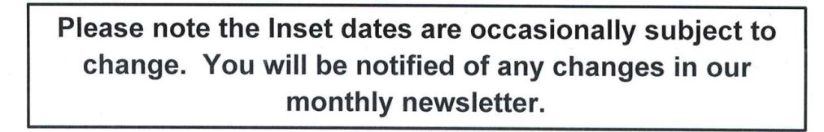
 |  | Inset Days

